ASSIGNMENT–2

PythonProgramming

|  |  |
| --- | --- |
| AssignmentDate | 29-09-2022 |
| StudentName | Algotwar Ganga Prasad |
| StudentRollNumber | 410719106007 |
| MaximumMarks | 2 Mark |

Question-1:

**1 . Importing Required**

**PackageSolution:**

import pandas as pdimport seaborn as snsimportnumpyasnp frommatplotlibimportpyplotasplt

%matplotlibinline

Question-2:

1. **Loading the**

**DatasetSolution:**

df = pd.read_csv("/content/Churn_Modelling.csv")df

**Output:**

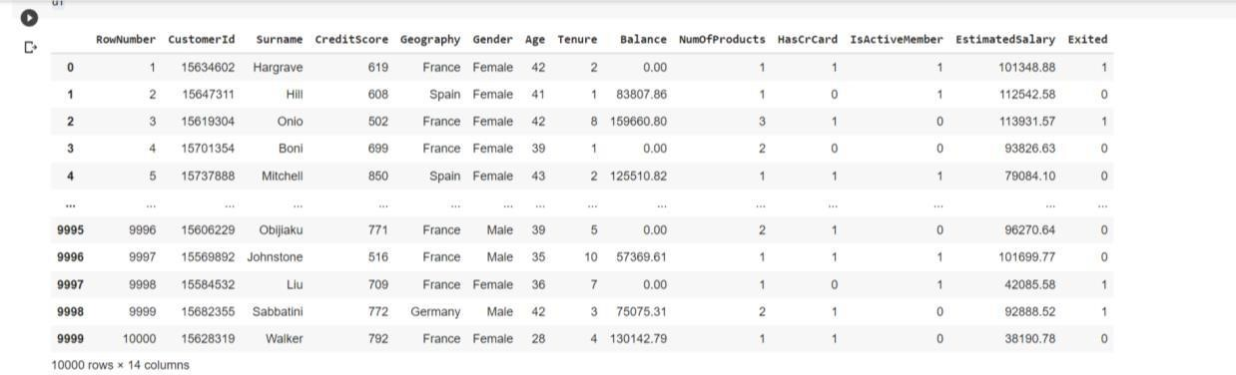

1. **Visualizations**

Question-3:

* 1. **UnivariateAnalysis Solution:**

sns.displot(df.Tenure)

**Output:**

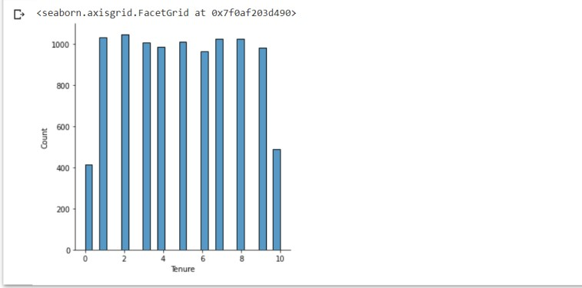

* 1. **Bi-**

**VariateAnalysisSoluti on:**

df.plot.line()

**Output:**

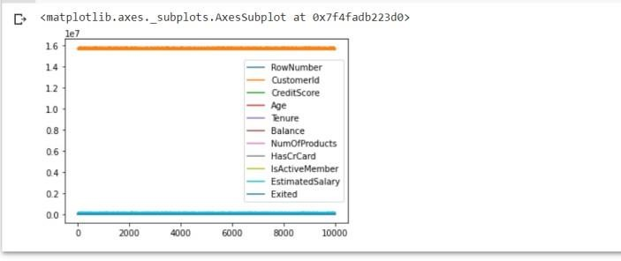

* 1. **Multi-**

**VariateAnalysisSolution:**

sns.lmplot("Age","NumOfProducts",df,hue="NumOfProducts",fit_reg=False);

**Output:**

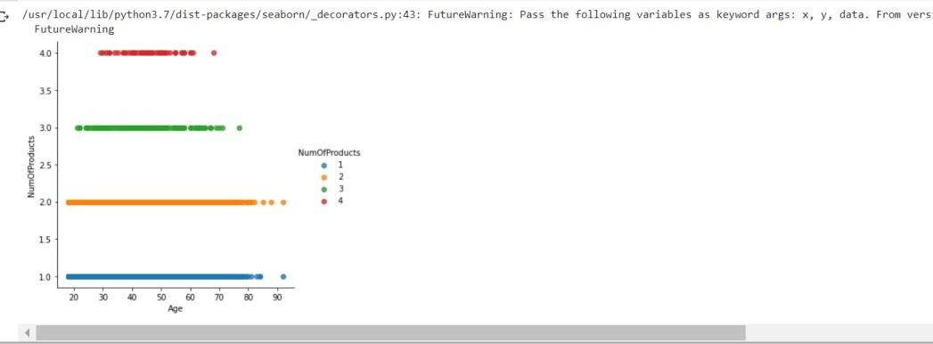

1. **Performdescriptivestatisticsonthedataset.** Question-4:

**Solution:**

df.describe()

**Output:**

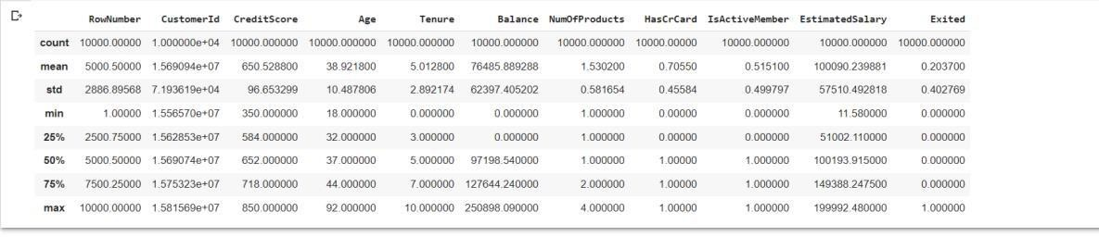

1. **HandletheMissingvalues.**

Question-5:

**Solution:**

data =

pd.read_csv("Churn_Modelling.csv")pd.isnu ll(data["Gender"])

**Output:**

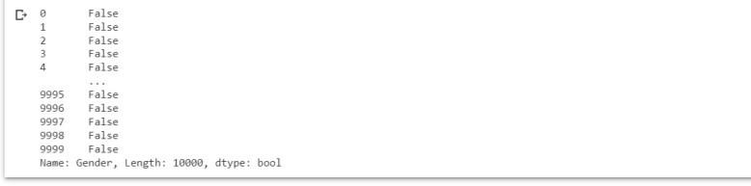

Question-6:

1. **Findtheoutliersandreplacetheoutliers.Sol ution:**

df["Tenure"]=np.where(df["Tenure"]>10,np.median,df["Tenure"])df["Tenure "]

**Output:**

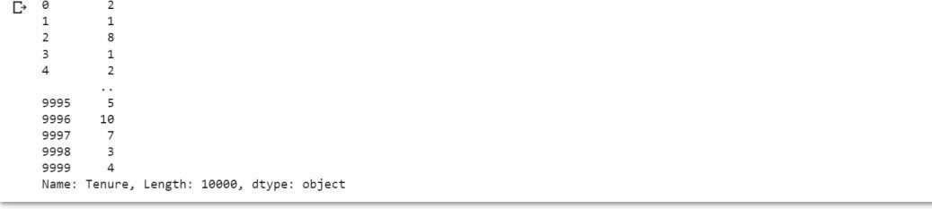

Question-7:

1. **CheckforCategoricalcolumnsandperformencoding.Sol ution:**

pd.get_dummies(df,columns=["Gender","Age"],prefix=["Age","Gender"] ).head()

**Output:**

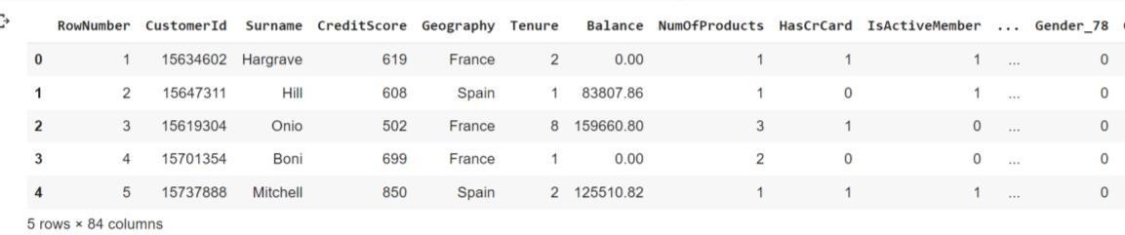

**Output:**

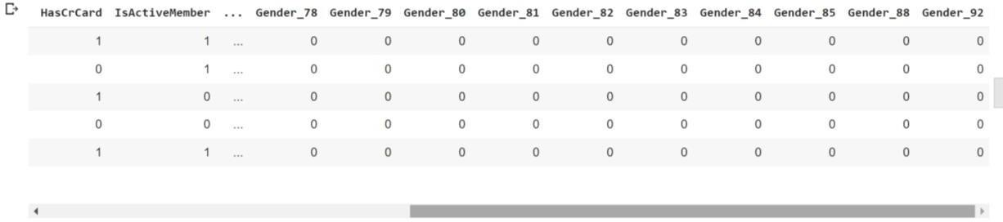

Question-8:

1. **Splitthedataintodependentandindependentvariables 8.1** **SplitthedataintoIndependentvariables.So lution:**

X=df.iloc[:,:-

2].valuesprint(X)

**Output:**

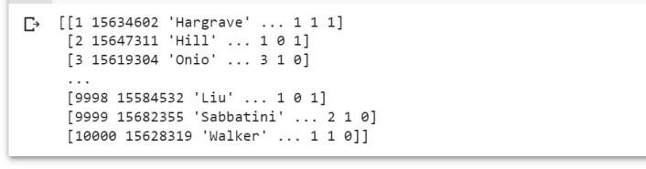

**8.2** **SplitthedataintoDependentvariables.So lution:**

Y = df.iloc[:, -

1].valuesprint(Y)

**Output:**



Question-9:

1. **Scale the independent variablesSolution:**

importpandasaspd

fromsklearn.preprocessingimportMinMaxScalerscaler=M inMaxScaler()

df[["RowNumber"]]=scaler.fit_transform(df[["RowNumber"]])print(df

)

**Output:**

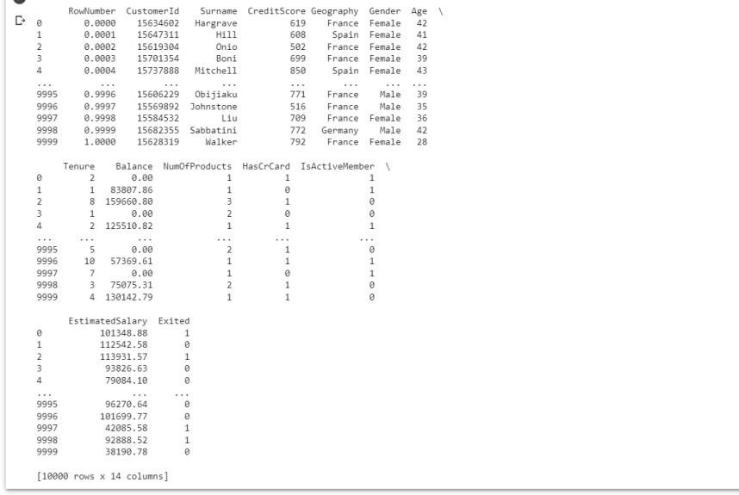

Question-10:

1. **SplitthedataintotrainingandtestingSol ution:**

fromsklearn.model_selectionimporttrain_test_splittrain_size=0

.8

X=df.drop(columns=['Tenure']).copy()y=

df['Tenure']

X_train, X_rem, y_train, y_rem = train_test_split(X,y,

train_size=0.8)test_size= 0.5

X_valid,X_test,y_valid,y_test=train_test_split(X_rem,y_rem,test_size=0.5) print(X_train.shape),

print(y_train.shape)print(X_valid.shape), print(y_valid.shape)print(X_test.shape),pr int(y_test.shape)

**Output:**

